**5 Festive Must-Not-Miss Suit Set Under 1999**

Festive season is here. Who doesn’t want to splurge? Yet we all are binded by our budgets, but compromise is not an option. It is festive season and we need to deck up our wardrobe for the fest eve. Not to worry, we have done some exploring and have come up with few excellent festive styles that are on sale and available under Rs. 1999 only. Trust us these are not part of the clearance sale, they **latest suit design** available at such an affordable price. Bonus is you don’t have to leave your comfort to get them, they are at your fingertips. You can shop these styles online and get free delivery of your order.

**Metallic Print Suit Set at Rs. 1999**

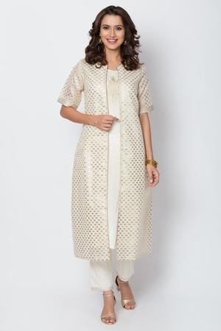

This is contemporary version of **straight suit** set, in which dupatta has been replaced by a smart shrug. The set comes with a sleeveless kurta featuring metallic floral print on the yoke paired with a matching regular pants and styled with metallic print shrug. It makes a gorgeous fusion wear and at this price, it is a hard-to-miss style.

**A Saree Kurta Pants Set @ 1899**

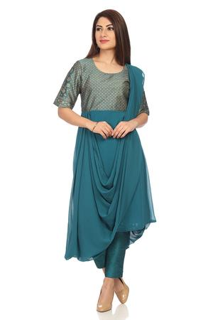

For those who love experimenting with their look, this is a perfect OOTD. This saree kurta inspired design is perfect to replace the lehenga set you are planning to buy for the fest. This style will not notch up your fashion quotient but at this price it save you a lot of money.

Cotton Anarkali @ 1799

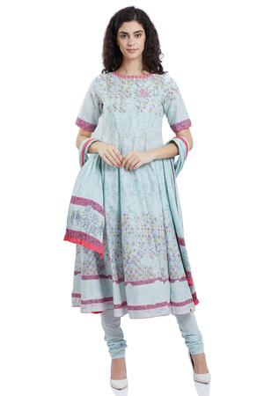

For those who just can’t ignore the comfort of cotton this cotton suit set in Anarkali style is a perfect option. It comes with a hint of pink on pastel blue, which is going to give your festive look a freshness. With the soothing appeal of cotton your hectic schedule of the eve will get some ease. This set comes with an Anarkali kurta, churidar and dupatta. At this price it is just unmissable.

A Red Toga Kurta @ 1999

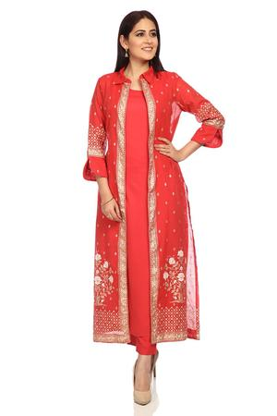

The allure of red is undeniable and when it comes to festive dressing, this color is the effortless way to get the spotlight. This style comes with a contemporary touch, having included a collared shrug with cut out sleeves paired with basic sleeveless kurta and slim pants. Available at such a nominal price, we wonder how long it will stay there.

**A Smart Kurta Pants Set @ 1649**

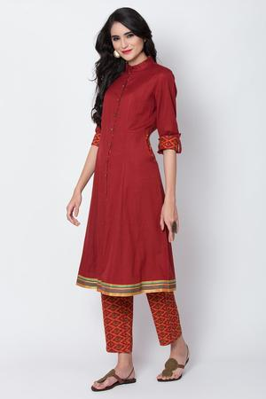

If you are the one who always admire adding a smart touch to your look whether it’s work wear or festive dressing, then your heart will go for this. This kurta pants set comes in elegant color and pattern combination with minimal highlighting. Available at such low price, it will not stay for long.

|  |  |
| --- | --- |
| https://www.biba.in/new-arrivals/suit-sets | latest suit design |
| https://www.biba.in/new-arrivals/suit-sets/straight | straight suit |
| https://www.biba.in/suit-set/fusion-wear | fusion wear |
| https://www.biba.in/suit-sets/lehenga-set | lehenga set |
| https://www.biba.in/cotton-suit-sets-collection | cotton suit sets |